Modifying Foam Pads for Doubles
by SilasX, 23 March 07
Many people find foam pads ill-suited for doubles mode due to how they slip apart while playing. In this FAQ, I present an easy, inexpensive, effective way to attach two foam pads together. It also allows the pad to be folded over for easy storage. Though I use the Red Octane Ignition pad in this example, it works for any pad of that type that has a hem around the outside. (The hem is the puffy cloth rim around the outside of the pad.)
This method requires four blanket pins (I use 2.5-inch pins). Blanket pins are essentially heavy-duty safety pins. They typically cost about 50 cents each. You may also find pliers to be helpful in closing the pins.
To attach the pads, you will basically be clipping them together on the lower hem in four places, each with a pin. Here is a view of the bottom of the pads, with the location of each pin indicated by a red arrow.
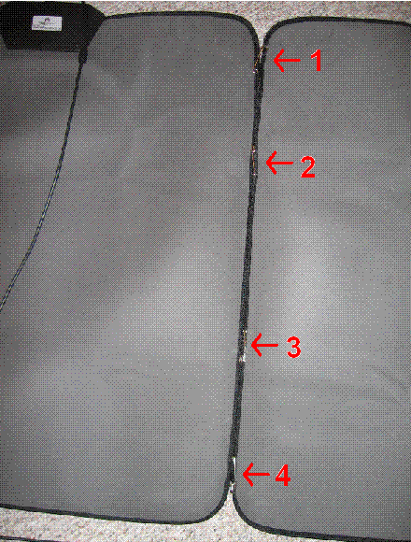
Pins 1 and 4 should be at the ends. Pins 2 and 3 should be about 9-12 inches from pins 1 and 4, respectively.
To insert a pin, open it, and then punch it in-and-out of one pad, then in-and-out of the the second, then in-and-out of the first, as shown in the four pictures below. Then close the pin as is done in panel 4 (this is where the pliers help.)
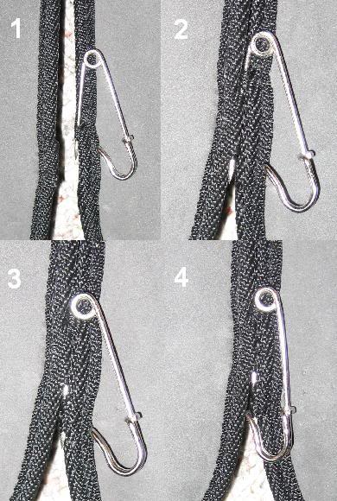
You do not need to make the third penetration, but regardless, make sure to alternate which pad you start from, and which way the pin is pointing. Also, try to leave at least a quarter inch between where the pin punches in and where it comes out so as to avoid a “tear-out” failure.
One advantage of this approach is that, since the pins are all along one line, you can easily fold it up for storage or transport, and you can indefinitely replace the pads while re-using the pins. See the picture below.
(Pins are circled in red.)
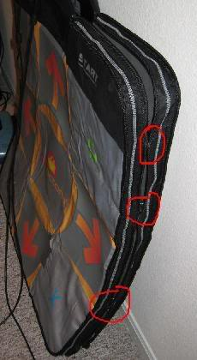
As for how well it holds the pads together, here are two videos of me doing nine-footers:
Candy, Heavy
Paranoia Evolution, Heavy (warning, out of sync)
Note how it also largely keeps the pad from sliding.
I hope you found this helpful. Special thanks to my mom and dad, who devised this solution when I visited them.

