What to do and what NOT to do in a routine
by HyperBroken, 3 February 02
FYI: Entertaining a crowd and a DDR Veteran are two different things. Anything as little as looking away from the screen will entertain a crowd, but for seasoned DDR veteran, you'll need to pull out all stops and bust out something never done before. Or just know how to 'dance'.
It takes many things for a quality routine. Technique, Flow, Content, Comedy, Corrdination, Shock Value, and Crowd Control. Any one of these alone will just not work.
One fine example is DJ 8-Ball. His routines are well thought out and practiced. Such as his Cafe Routine, or his Synchronized Love routine.
Even more so, Kevin Kim's Dam Dariram Routine foreshadows just about everyone in California. Not only does he have excellent technique, but 1. his arms techniques are ALWAYS clean, which is hard to say about most other freestylers here, and 2. his routine shows that he's put A LOT of practice in it.
Costumes alone will not win a tournament. Sure, it looks different from regular clothing, but if don't do anything special with it, might as well wear regular clothes. If you dress as a samurai, wield a sword. If you dress as a DBZ character, do some energy blast. If you dress as a breaker, for god sakes, B-BOY! ^_^
Relying on a single freestyle move will not win a tournament. I don't care if you defy gravity. If you rely on just one thing, you are on your own. Adding variety will better your chances.
On a related topic, sticking to overplayed, overused moves like these will (greatly) lessen your chances of placing.
Example:
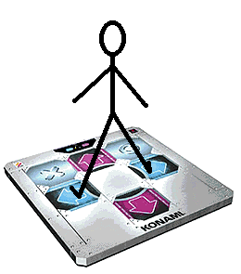
*These moves are a Avoid at all costs.* (image by jmdbcool)
Most importantly of all, you must put a lot of time and practice in your routine. No one likes to see a really good, but sloppy routine, where the arms are flopping everywhere. The more time you commit to practicing your routine, the better looking your routine will come out. Practice is your friend.
Experience is also your friend. You can read freestyling tips as much as you like, but unless you go over and check out an actual tournament and do a routine, you'll never really find your true freestyle potential. Goto tournaments, check out placing routines, and have a feel for it. You can only get better by going out there and testing your mettle. After that, download the vids, and use that as building blocks for your next routine.
Finally, DO NOT COPY SOMEONE ELSE'S ROUTINE. You will be shunned as a result. Add your own flair, your own style and taste. People are looking for something different, not 25 routines of the same thing.
That is all. Good luck and have fun!

