The business card trick is perhaps one of the greatest tricks one can know when maintenance a DDR machine. It's simple, quick, easy, and best of all, cheap!

Here's what you'll need:

- Screwdriver (Philips if it's a DDR machine, Hex if it's ITG or PiU)
- Business cards/cardstock
- Permission to work on the machine

[b]Step 1: Testing the Pads[/b]

Before you get started, first you need to diagnose the problem. Doing this is simple. In the game's service menu, go to the I/O test (where you can test the pad inputs). All machines have a slightly different interface for this test, but generally speaking, it should show you when one or more of the sensors within a specific arrow are activated. Once you understand the information on the Input screen, we can get begin.

First, let's begin with the arrow that you suspect is the culprit. With the toe of your shoe, or your thumbs, press down on the panel where each sensor is located. This would be the top, bottom, left, and right edges of the arrow panel. Press down on each sensor, one at a time. When you do this, notice how much pressure you have to exert before the pads light up or the machine registers the input. After you have done this to all four sensors, does a certain sensor feel "weak" to you? If so, then that is probably the sensor that needs help.

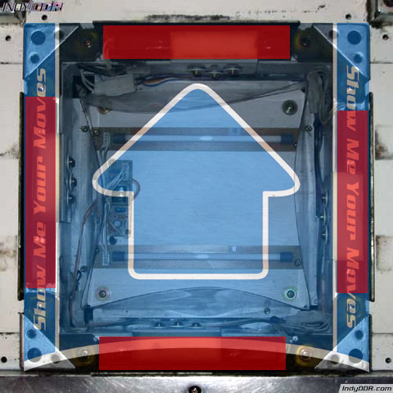
[b]Step 2: Identifying the Problem[/b]

Now that you've identified the unresponsive sensor, it's time to get to work.

Access the arrow cavity be unscrewing the brackets and removing the arrow panel. Once that's done, pull the weak sensor out from it's housing (keep the wires connected). Hold the sensor between your thumb and index finger and squeeze it in the middle. Does it activate? How hard are you having to push it? If it doesn't activate at all, your sensor is dead and you have to replace it. If, however, it is still activating when you squeeze it, then there's hope.

Keep in mind that if your sensor still works, but it takes a lot of pressure to activate it, the business card trick might not be enough to make it functional again. In this case, you should replace that sensor with a new one.

[b]Step 3: The Business Card Trick[/b]

Here we go! Let's get that sensor operational again!

Take a business card and fold it over in thirds along the length of the card (see the diagram below form an example). Take the folded card and place it under the sensor, inside the sensor cavity as shown in the diagram.
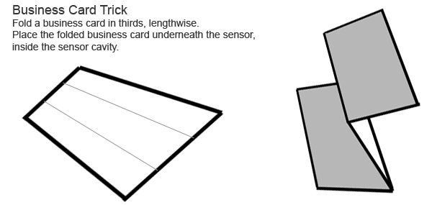

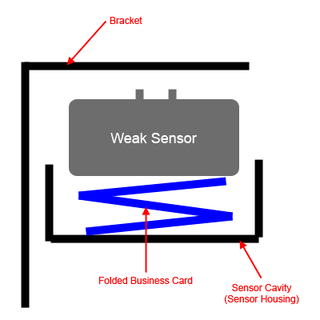

Do this for any sensors that might be weak or unresponsive for that arrow/pad and give it another test. Hopefully the pads will be much more responsive.

[b]Step 4: Explanation and Warnings[/b]

This trick works by adding some pressure to the bottom of the sensor. Then, when the player presses down on the arrow panel, it requires less force to activate the sensor, because of the business card pushing on it from underneath.

In some cases, having a full business card folded underneath a sensor might make it too sensitive, which will lead to "ghost stepping". This is when the sensor will activate, even when no was seems to be hitting it. If you're having this issue with an arrow you used the business card trick on, you should take out the full business card and use half a business card instead. And in some instances, it might be necessary to use an additional business card on some very stubborn sensors.

Well, that's all. I hope this helps some of you out and give extra life to those aging arcade cabinets out there.

